Order to Cash:

Sequncing need to set:
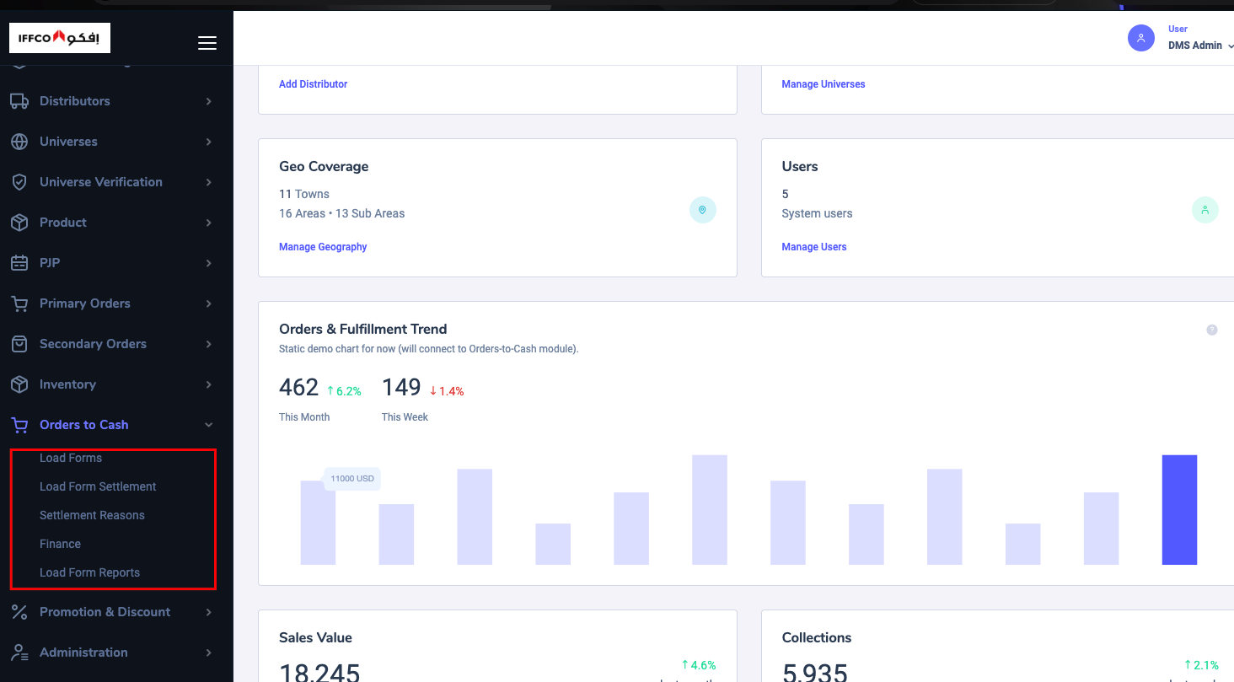

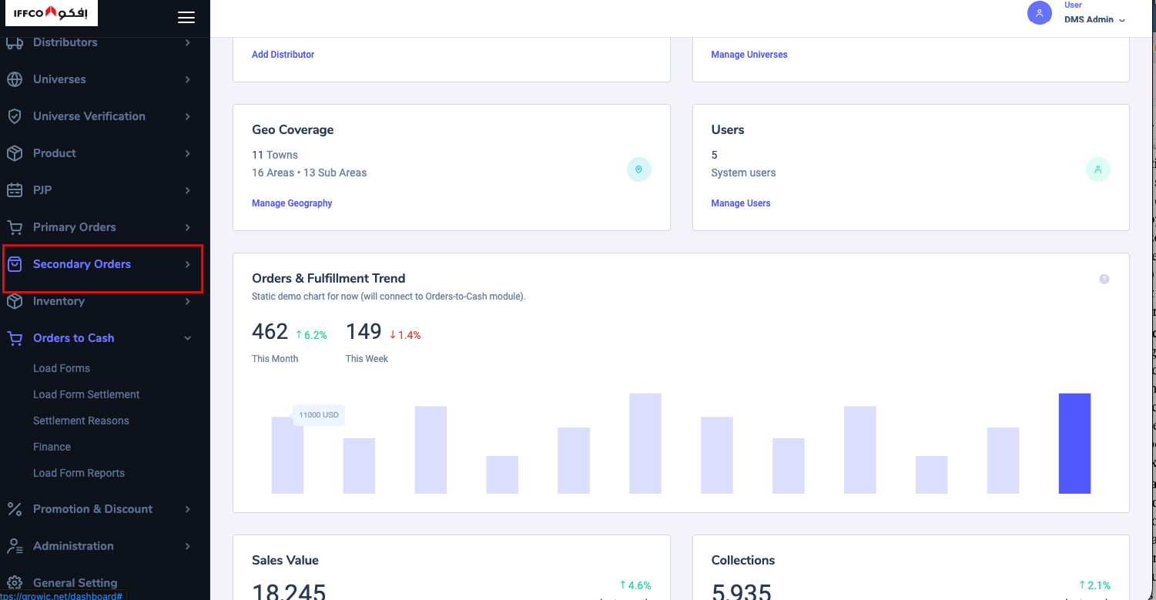

Main Menu – Order to Cash (Sequencing of sub menu) :

- Secondary Order
- Load Form (Generate)
- Load Form Grid
- Invoice Grid
- Load Form Settlement
- Finance Menus(Store Ledger, Deliveryman Ledger, Payment collection of both Credit Policy for store )
Order Vs Execution:

- Show proper setting name: 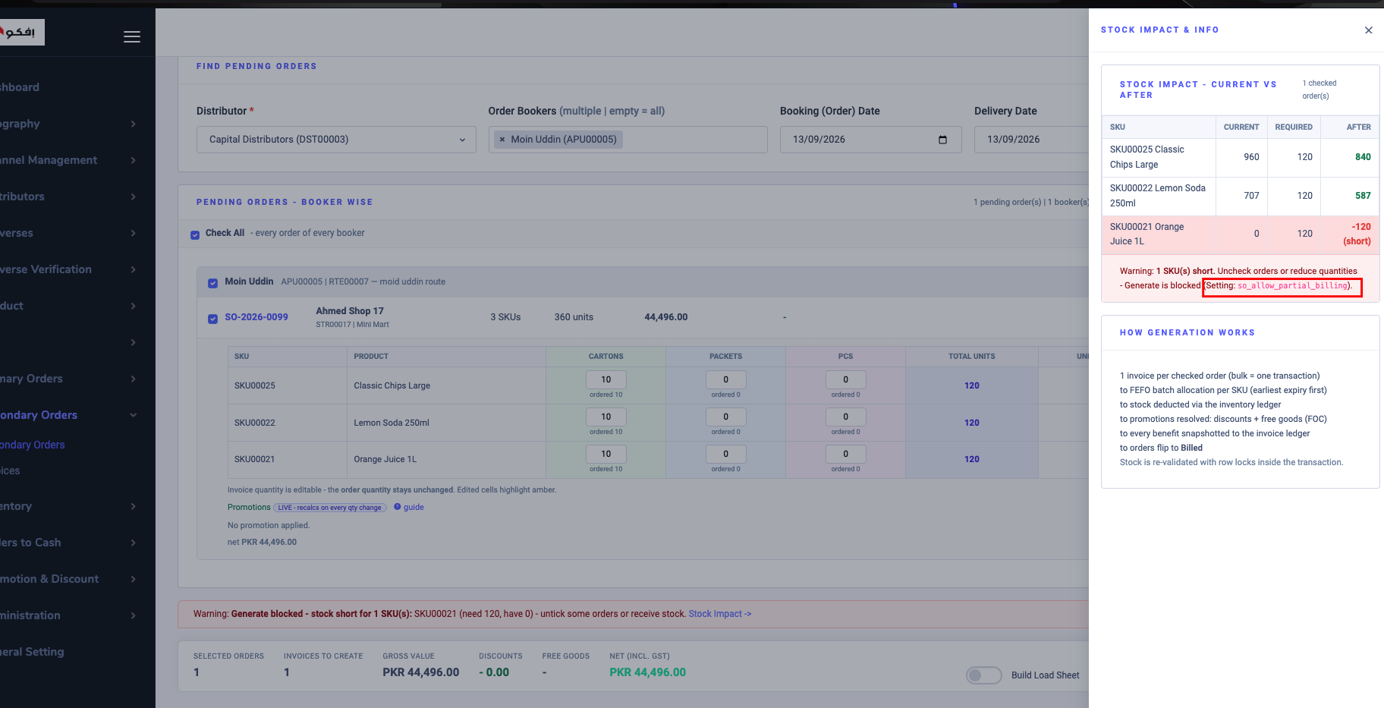

- Load Sheet is mandatory for any delivery.
- 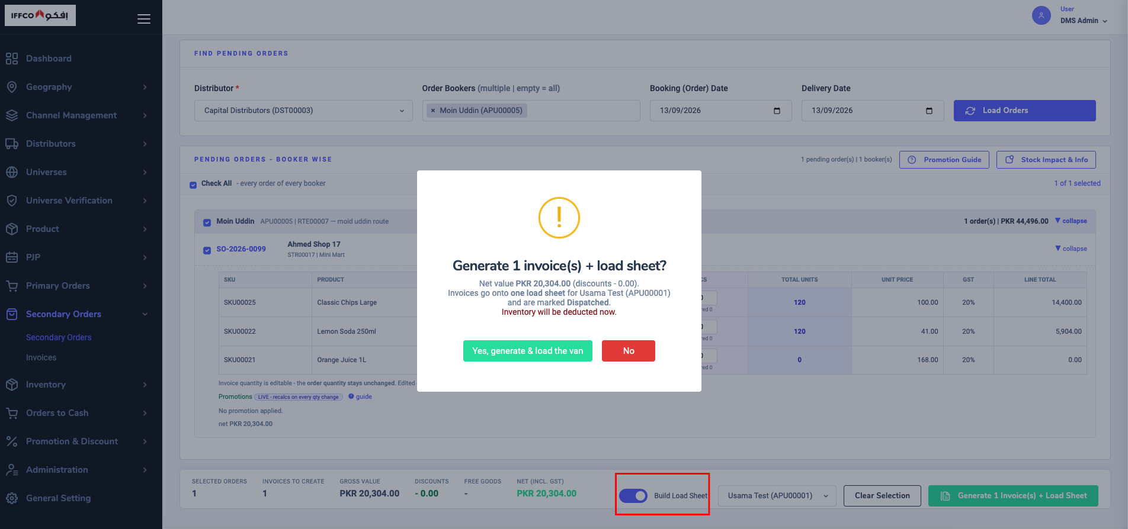

- When I lick on Invoice it change the Menu: 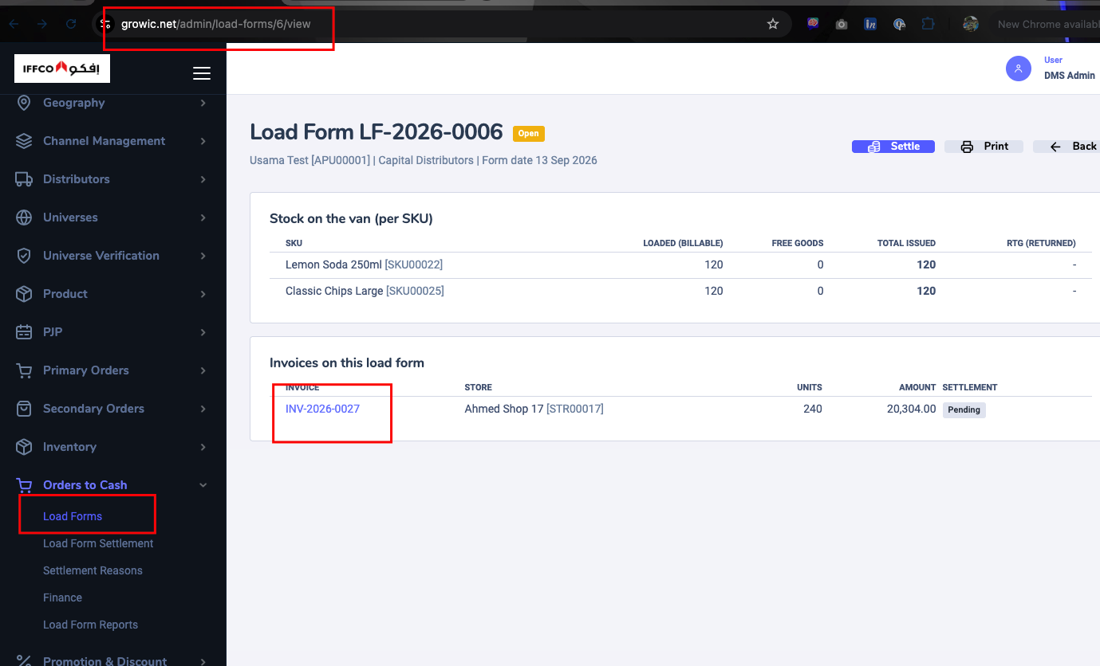
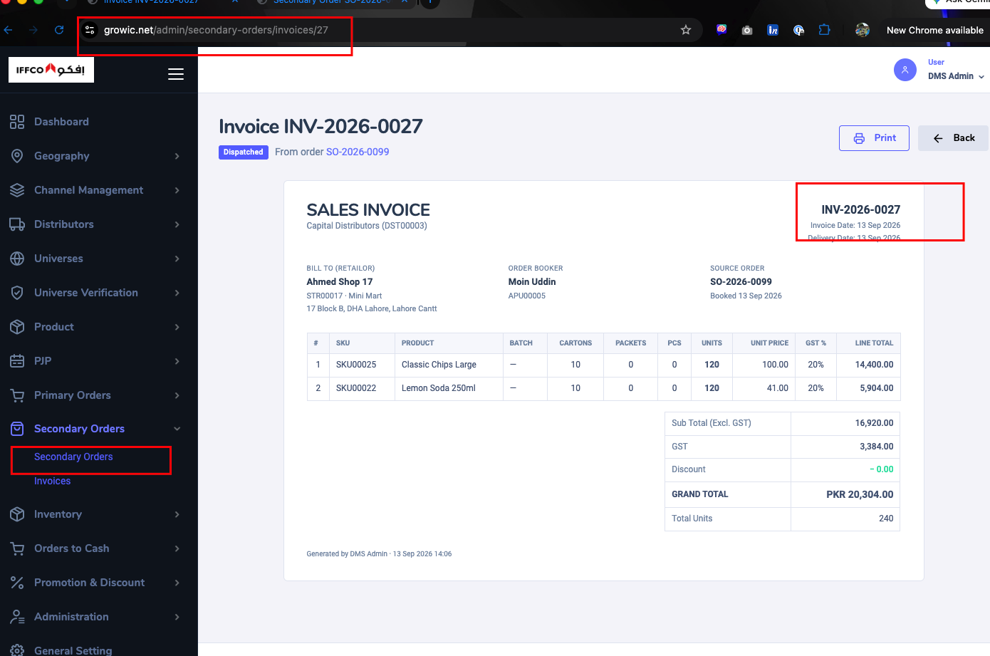
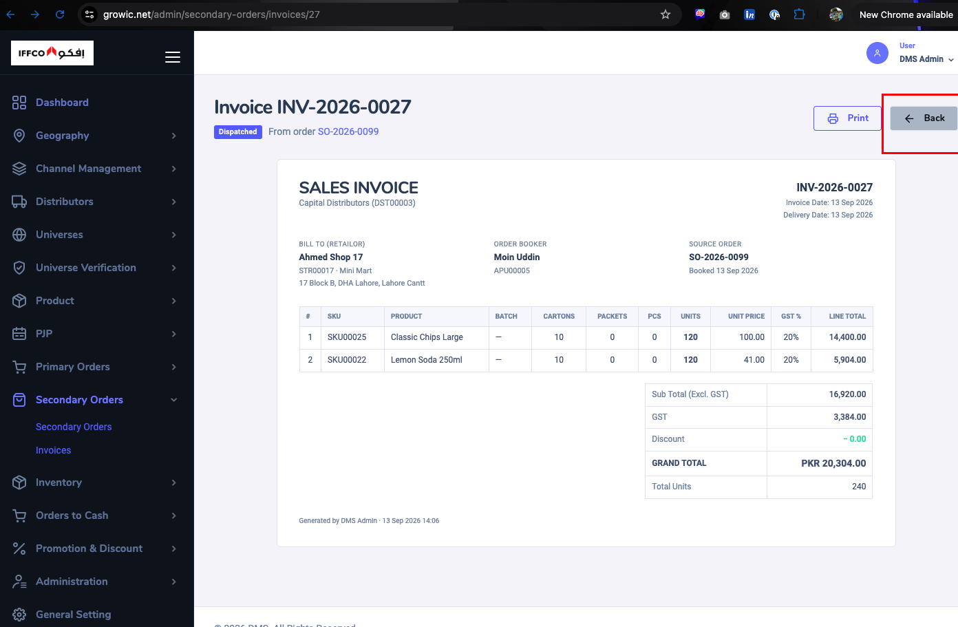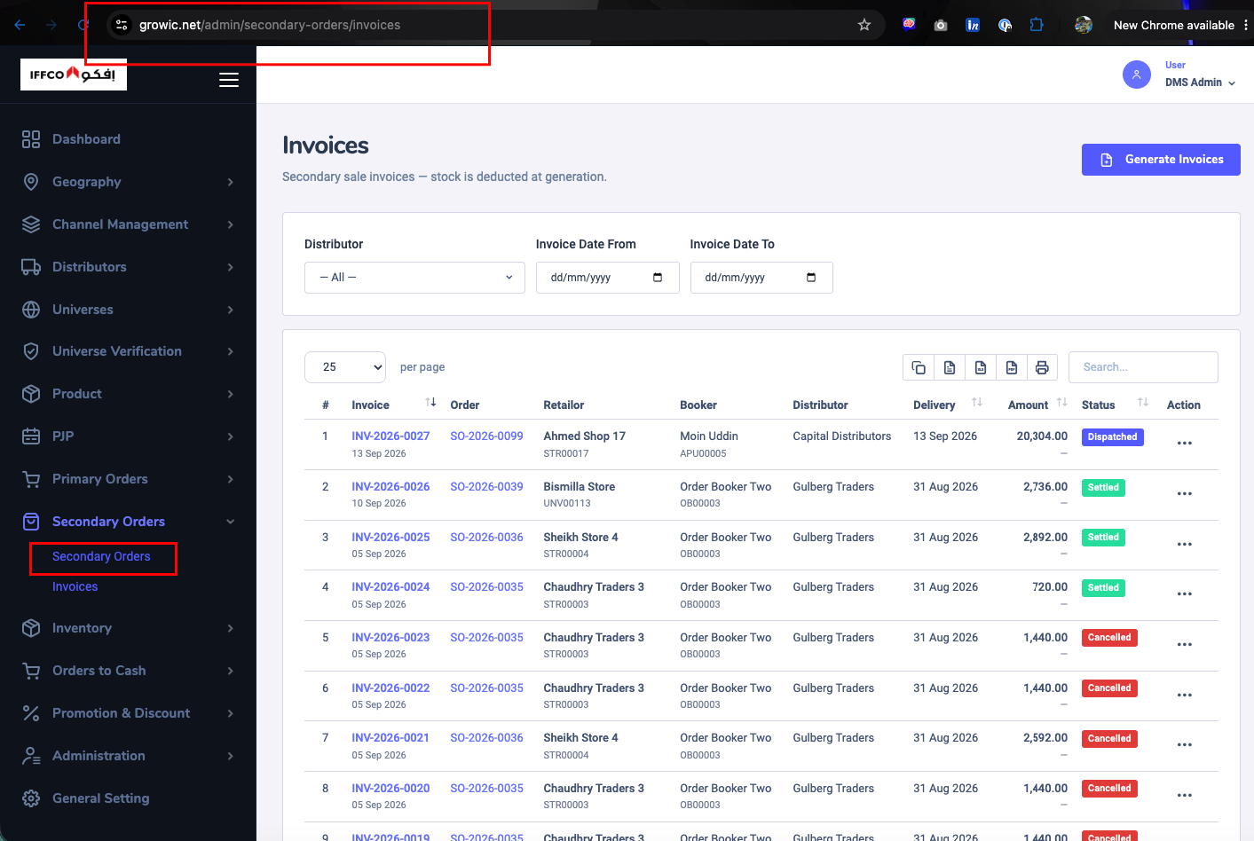

- 2

AI Generated color – (Please use different color or prompt style) and DO not use “—“ Instead “-“.

